Step1: Login to <https://portal.azure.com> and create a new Azure Web App with name “fcvmapp” in resource group “fc3TierVnetResourceGroup”. Settings are shown below.

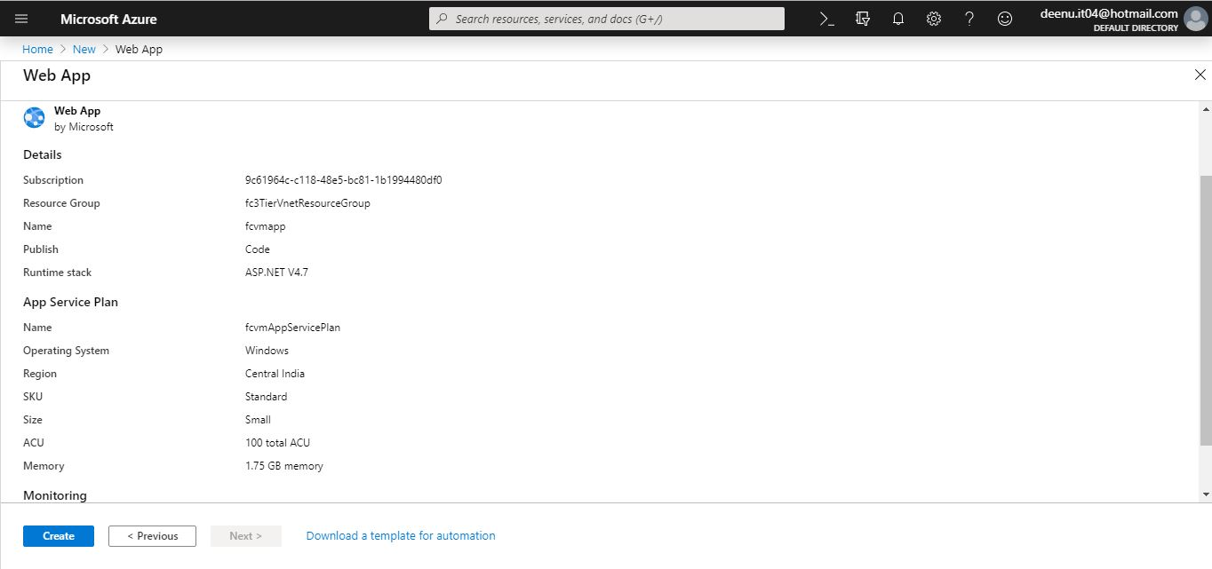

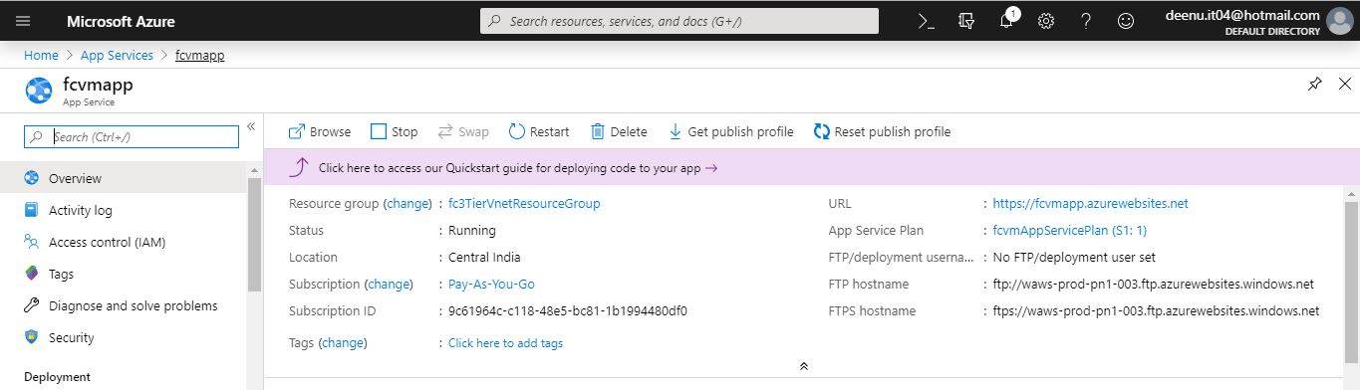

Step2: Enable authentication and authorization for Web App

1. From the left menu, select Authentication / Authorization, then enable App Service Authentication by selecting On.
2. In Action to take when request is not authenticated, select Log in with Azure Active Directory.
3. Under Authentication Providers, select Azure Active Directory

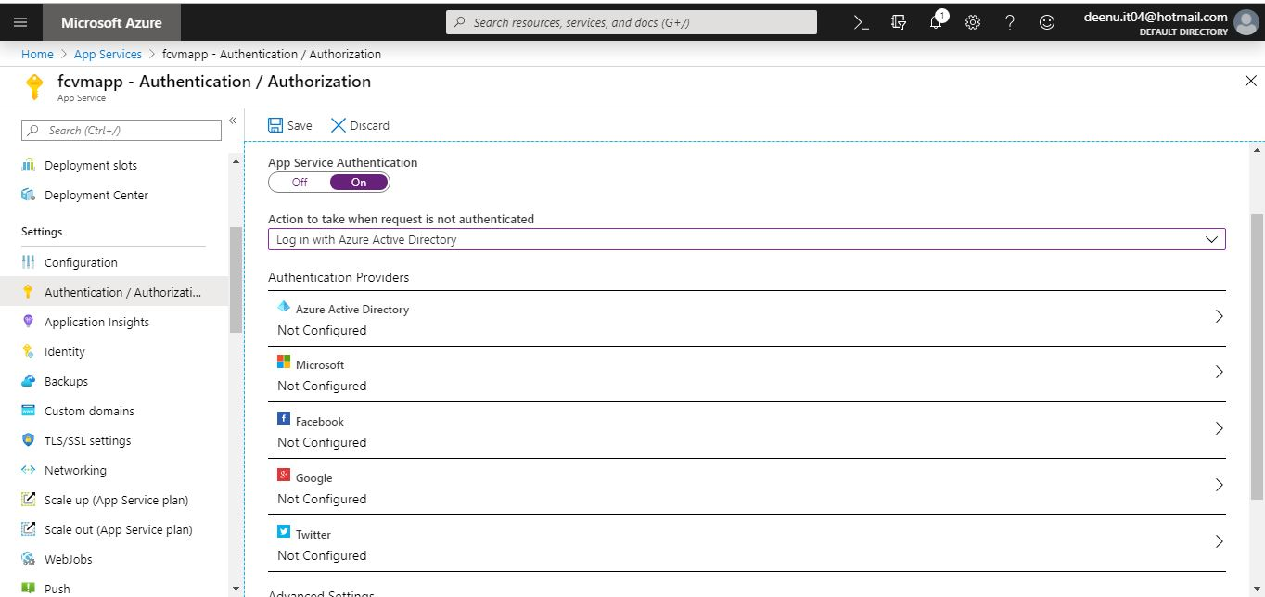

1. Select Express and accept the default settings to create a new AD app and select OK.

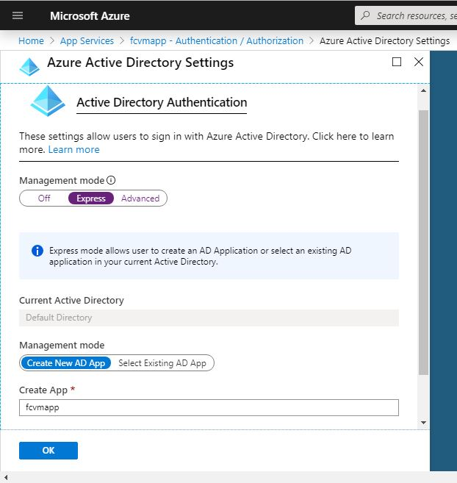

1. In the Authentication / Authorization page, select Save.
2. Select Azure Active Directory again, and then select the Azure AD App.

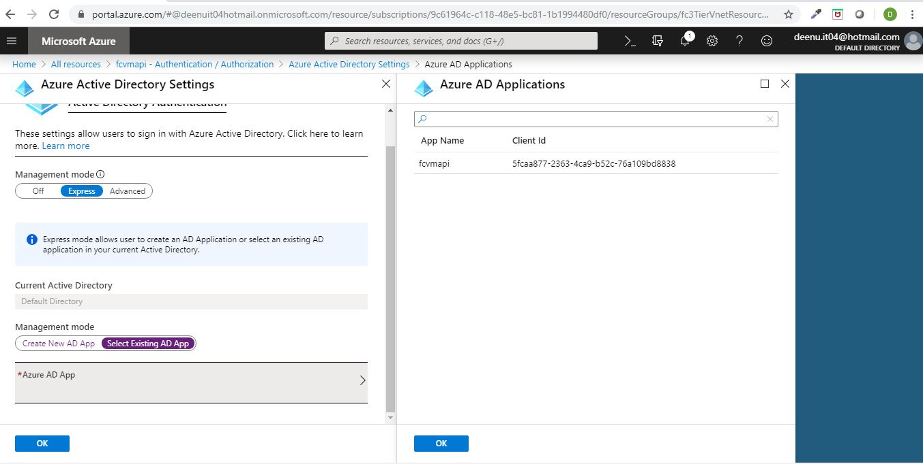

Step5: Grant fcvmapp access to back end fcvmapi.

1. Go to Azure Active Directory -> App registrations.

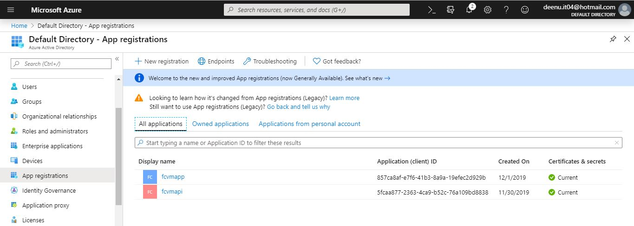

1. Select **fcvmapp** AAD app.

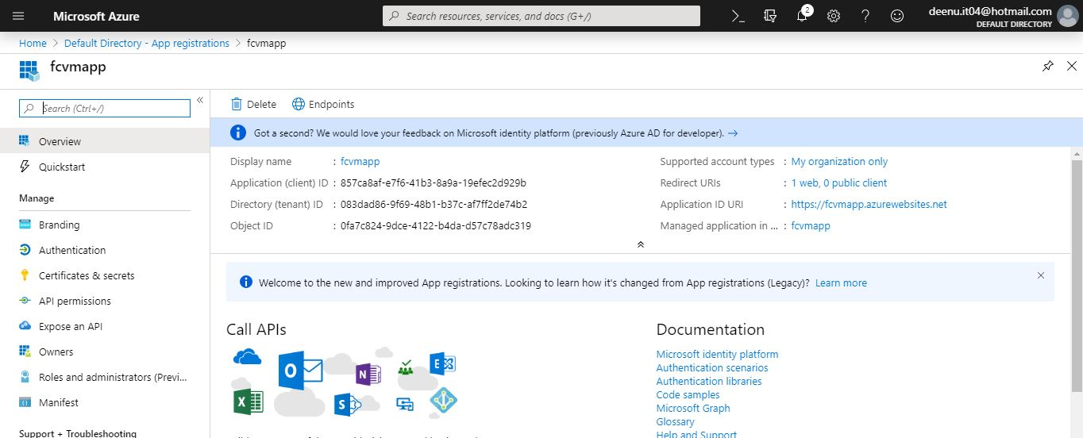

1. From the left menu select API permissions. Then click **Add a permission**.

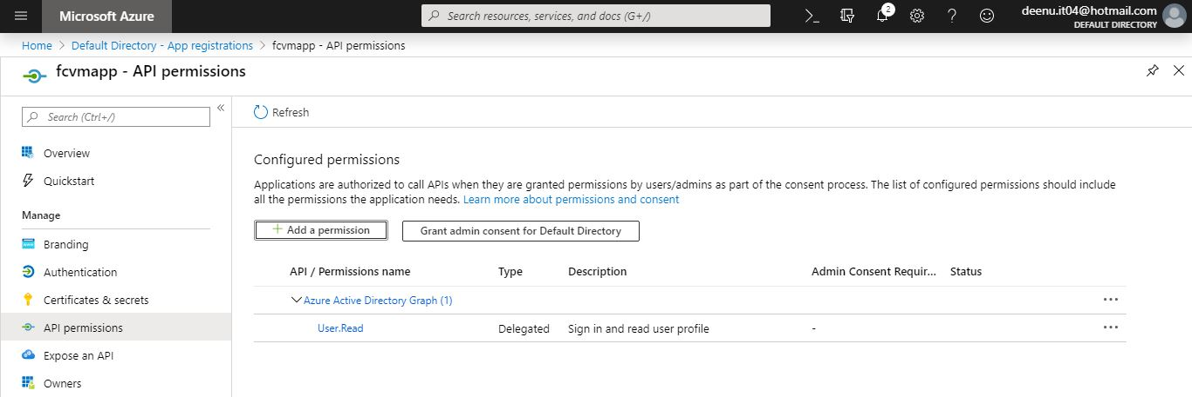

1. Select **fcvmapi** from the app list

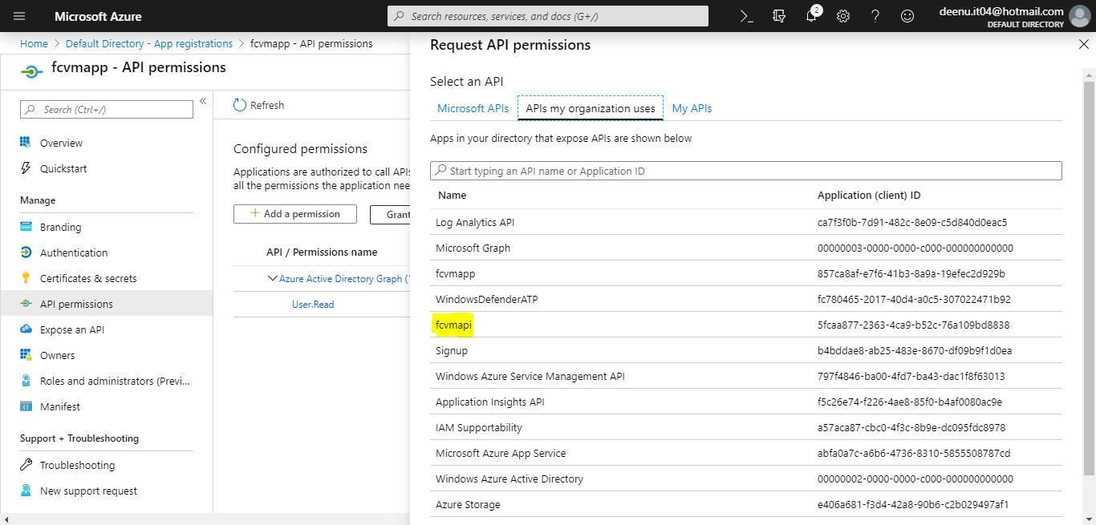

1. In the Request API permissions page for the back-end fcvmapi, select Delegated permissions and user_impersonation, then select Add permissions.

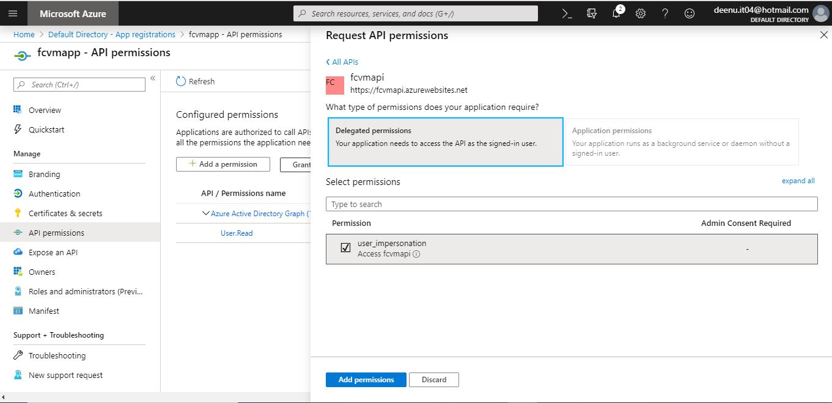

Step6: Configure App Service to return a usable access token.

1. Sign in to Azure Resource Explorer (<https://resources.azure.com/>). At the top of the page, click **Read/Write** to enable editing of your Azure resources.

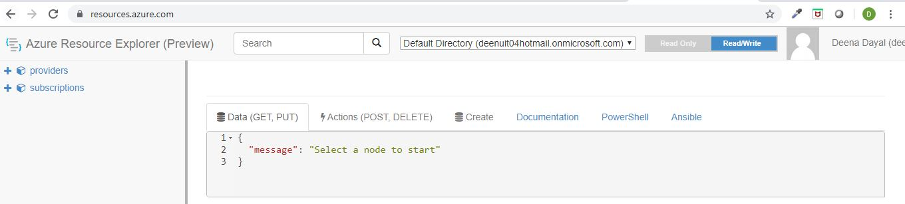

1. In the left menu, click subscriptions > <your-subscription> > resourceGroups > fc3TierVnetResourceGroup > providers > Microsoft.Web > sites > fcvmapp > config > authsettings.

In the authsettings view, click Edit. Set additionalLoginParams to the following JSON string, using the client ID you copied.

"additionalLoginParams": ["response_type=code id_token","resource=5fcaa877-2363-4ca9-b52c-76a109bd8838"]

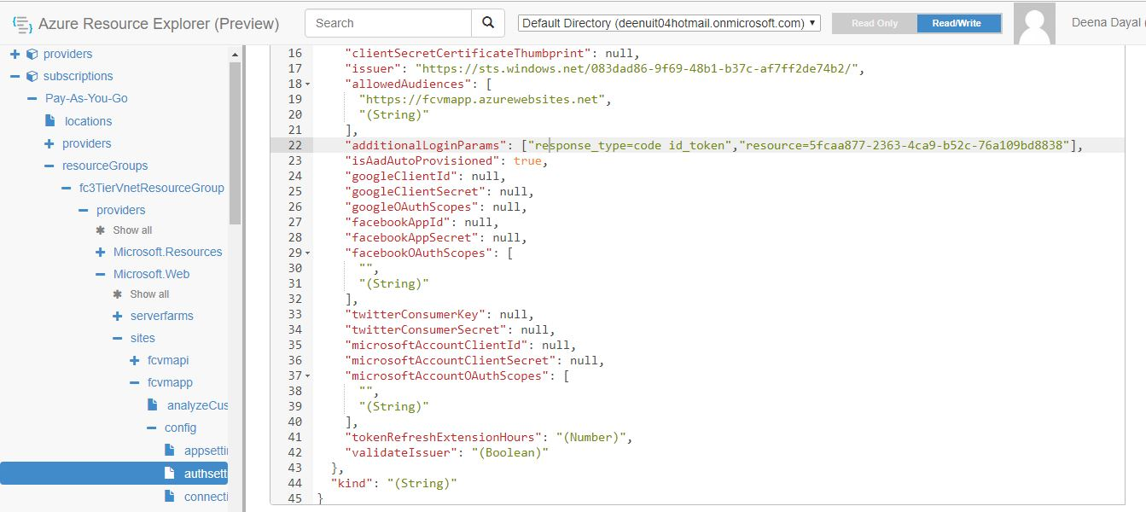

1. Then click PUT button

Step7: Open the **ManageAzureVMApp** project in Visual Studio.

1. Publish the Web Application in Azure using Visual Studio Web Deploy. Publish profile information can be downloaded from azure portal.

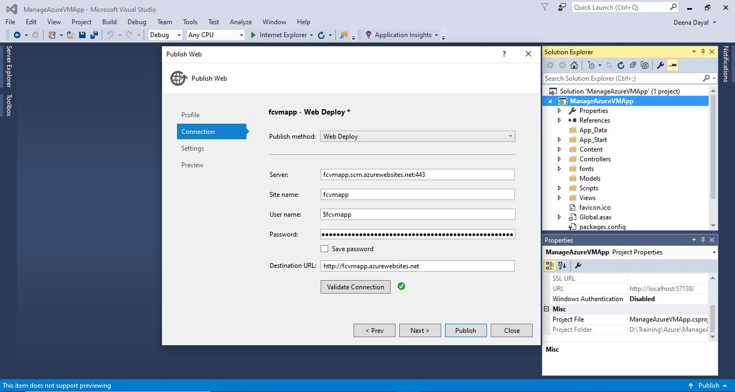

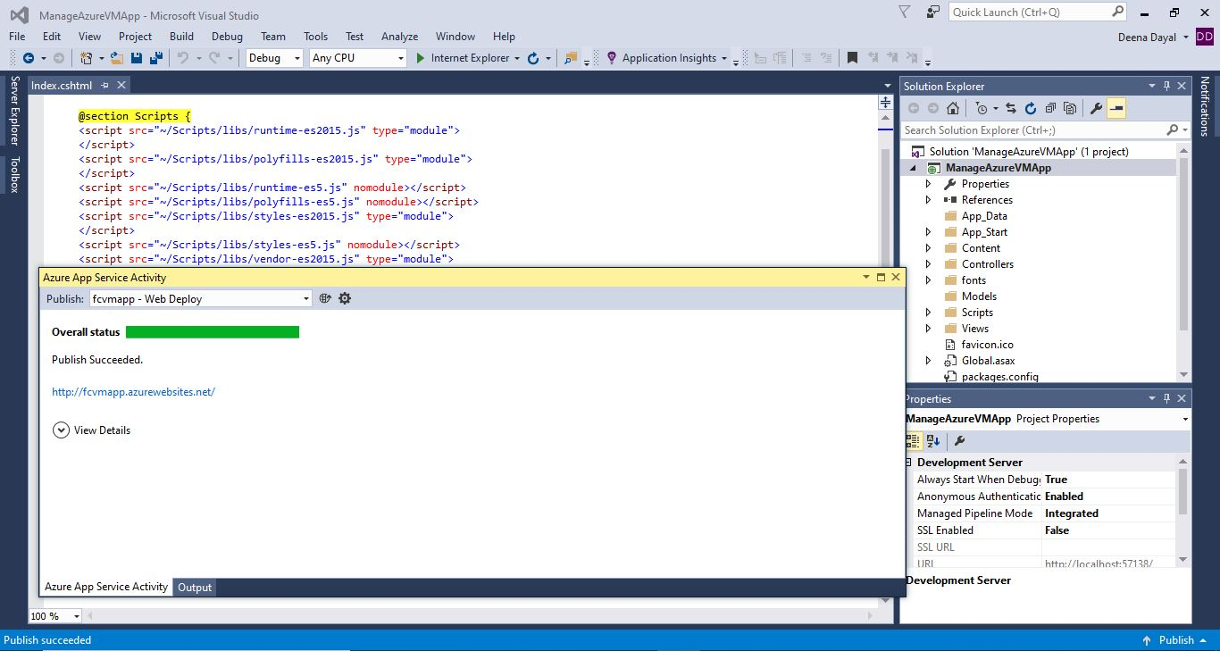

Step8: Verify the Angular based web application by browsing <https://fcvmapp.azurewebsites.net/>

